**A PROJECT REPORT**

**ON**

“SMART FARM MANAGEMENT SYSTEM”

**SUBMITED TO**

SAVITRIBAI PHULE PUNE UNIVERSITY

**IN PARTIAL FULFILLMENT OF THE REQUIREMENT OF**

T.Y.B.B.A (COMPUTER APPLICATION)

SUBMITED BY: -

**Mr: - Sawant Ganesh**

**Miss: - Gawade Divya**

**UNDER THE GUIDED OF**

**Prof. Unde M.A**



SHRI CHHATRAPATI SHIVAJI MAHAVIDYALAYA,

SHRIGONDA-413701 (2023-2024)

SHRI CHHATRAPATI SHIVAJI MAHAVIDYALA SHIVAJI NAGAR, SHRIGONDA-413701, DIST-AHMEDNAGAR



Date: / /2023

**CERTIFICATE OF PROJECT COMPLETION**

**Certified that Project Work Reported**

**“ SMART FARM MANAGEMENT SYSTEM”**

Has been completed satisfactory in partial fulfilment of T.Y.B.B.A

(Computer application), Course of **“SAVITRIBAI PHULE PUNE UNIVERSITY”** For the academic year 2023-2024 by the following student of

**“SHRI CHHATRAPATI SHIVAJI MAHAVIDYALAYA”,** SHRIGONDA.

**Name of the Student: -**

**Mr: - Sawant Ganesh**

**Miss: - Gawade Divya**

**Place:** Shrigonda .

**Principal**

S.C.S.M. SHRIGONDA.

**Internal Examiner Sign** **External Examiner Sign**

**ACKNOWLEDEMENT**

I would like to take this opportunity to express my gratitude toward all the People who have in various ways, helped in the successful completion of my project.

I must convey my gratitude to **Prof. Unde sir** for giving me the constant source of inspiration and help in preparing the project, personally correcting my work and providing encouragement throughout the project.

I also thank all my faculty members for steering me through the though as well as easy phase of the project in a result-oriented manner with concern attention.

Thank You

**INDEX**

|  |  |
| --- | --- |
| Sr.no | **CONTENT NAME** |
| 1 | Abstract |
| 2 | Introduction |
| 3 | Features of project |
| 4 | Scope of System |
| 5 | Systems Analysis |
| 6 | Fundamentals Of System |
| 7 | System Design |
| 8 | Hardware and Software Requirement |
| 9 | Conclusion. |
| 10 | Future Scope. |
| 11 | Bibliography |

**ABSTRACT**

Modern agricultural systems have been developed application of fertilizer, soil, climate, crop rotation, and genetic manipulation of crop plants. Each practice is used for soil, farming system each depends on the others and need for using the others. The work of fertilizer in agricultural production, has been key to the development of these practices. the different module more technology in agriculture. user details and problems different place solved for officer. Development process overall provider suggestion agriculture is that it will continue on throughout the future, providing for those who need us most.

Smart agriculture, in abstraction, encompasses the integration of cutting-edge technologies and data-driven insights to revolutionize farming practices, optimize resource utilization, and enhance productivity while minimizing environmental impact. At its core, smart agriculture leverages advanced sensors, Internet of Things (IoT) devices, artificial intelligence (AI), and data analytics to create a connected ecosystem where every aspect of farming, from soil management to crop health monitoring, is meticulously monitored and managed in real-time. This abstraction involves abstraction involves abstracting vast amounts of data into actionable insights, facilitating informed decision-making for farmers and stakeholders. It envisions a future where traditional farming methods are seamlessly blended with digital innovations, fostering sustainability, efficiency, and resilience in agricultural systems.

**INTRODUCTION**

Farm software centralizes, manages, and optimizes the production activities and operations of farms. With farm software, farmers can become strategic and efficient in their daily farm related tasks and responsibilities. Farm software automates the recording and storage of farm data, monitors and analysis farm activities and consumption, and tracks business expenses and farm budgets. Additionally, the software can support farm financial management with accounting programs, farm planning and procurement functionality, and marketing and budgeting tools.

While farm software all solve overlapping production and yield concerns, the scope of the former is larger and more comprehensive. Furthermore, specialized farm management solutions exist, tailoring the record-keeping and farm production monitoring functionalities to the specific business needs of dairy or cattle farms, grain farms, cannabis farms, and other types of agribusinesses. However, vendors do offer more generalized, sector-agnostic farm management solutions, benefiting farmers, ranchers, growers, and other agribusiness employees who manage and oversee operations that are multi-sector.

**FEATURES OF SYSTEM**

Improved user experience the website redirects the user to farmer resource management system and according to the user's needs it will display the page. The user can Register and login easily and can avail the services provided and he or she can fill the details. And those details get updated Database. As the data is updated in real time, it is secure and efficient. This is a less time consuming and hassle-free process for the users as there is no discrepancy in the information they receive.

* Emergency services management
* Less time consuming
* Time-saving Technology
* Improved Efficiency
* Reduces scope for Error

**SCOPE OF SYSTEM**

Smart farming uses modern information and communication technologies to manage farms. It helps farmers to:

* Understand factors: Understand important factors like water, topography, vegetation, soil types, and aspect
* Use resources sustainably: Manage scarce resources in an environmentally and economically sustainable way
* Reduce waste: Reduce waste and enhance productivity
* Optimize human labour: Optimize the human labour required
* Increase control: Increase control over production, leading to better cost management
* Trace anomalies: Trace anomalies in crop growth or livestock health
* Boost efficiency: Boost efficiency through automation

**EXISTING SYSTEM**

IT is the study of farmer as a product of food and other raw material who occupies a strategic position in the economic life of a country. Farm management investigation give trust and direction to farm business improvement by providing useful information to planner

farmers and extension workers.

     The problem and the query is not solved in the give time. The users to interact with the existing system the website do not have all the services that would help for the farmers the farming system that significantly contribute to the agriculture of india are subsistence farming organic farming industrial farming. region throughout India differ in type of farming they use some are based are based on horticulture, ley farming agroforestry and many more.

**Disadvantage**

1) High initial costs.

2) Complexity.

3) Reliability and connectivity.

4) Unlimited use of pesticides.

5) increase use of pesticides and fertilizers.

**PROPOSED SYSTEM**

Smart farming and automatic connected devices real time monitoring and analysis.  
the farm and performing task ranging the from planting an watering harvesting and sorting , this new of Smart Farming.  
one of the most useful task drones can task on  is remote monitoring and analysis of fields  and crops . imaging the benefit of using a small fleet of drones instead of team up .  
increasing crop yields saving , water, protecting local water resource from runoff , saving On increasing the farmer profitability. soil moisture sensors.  
drip irrigation saving the water , water balance storing the water ponds.

**Advantage of System**

This Lead to More Efficient System.

Reduce time efficiency and increase work productivity.

Manage a Farm electronically.

**FUDAMENTAL REQUIREMENT**

**LOG IN MODULES**

In the module the customer, Skyler, farmer, worker and the admin can the log in the system by entering password and log in id, system open main account page after log in.

**CUSTOMER MODULES**

In this module customer can register to the application by entering profile details customer. can purchase the product which is uploaded by administrator.

**SELLER MODULES**

The farmer is the also seller where they can sell their product online. the system will display farm production on the main page of the application.

**WORKER MODULE**

This farmer is the also seller their where they can register by entering their details and experience also as their expectation. the labour also purchase the farm product. the farmer can heir the worker in this module.

**DASHBOARD MODULE**

Dashboard module is for the administer, and employee. in the module admin has complete setting of the application. employs can manage. All record in the database

**LOCATIONMODULE**

This is a master page admin can add the location like country, state, city, village

**PRODUCT MODULE**

This module farmer and seller can their can sell their products online.

It can another options farmer can sell their production online.

**BILLING REPORT**

The system can generate billing after purchasing the product. the system

calculate total cost automatically. It displays customer details, billing

details, and purchase product information.

**System Design**

System design is transition from a user oriented document to programmers or data base personnel. The design is a solution, how to approach to the creation of a new system. This is composed of several steps. It provides the understanding and procedural details necessary for implementing the system recommended in the feasibility study. Designing goes through logical and physical stages of development, logical design reviews the present physical system, prepare input and output specification, details of implementation plan and prepare a logical design walkthrough

* **System Analysis:**

The system analysis approach emphasises a closed look on all parts of the system. The analyst must consider all the system elements, their inputs, outputs, control, feedback and the environment when the system is being constructed.

* **System Design:** The goal of system design phase is to produce a model or representation of the system, which can be used to build the system. Here the emphasis is on translating the requirements of the system into design specification.

.

**DFD DIAGRAM**

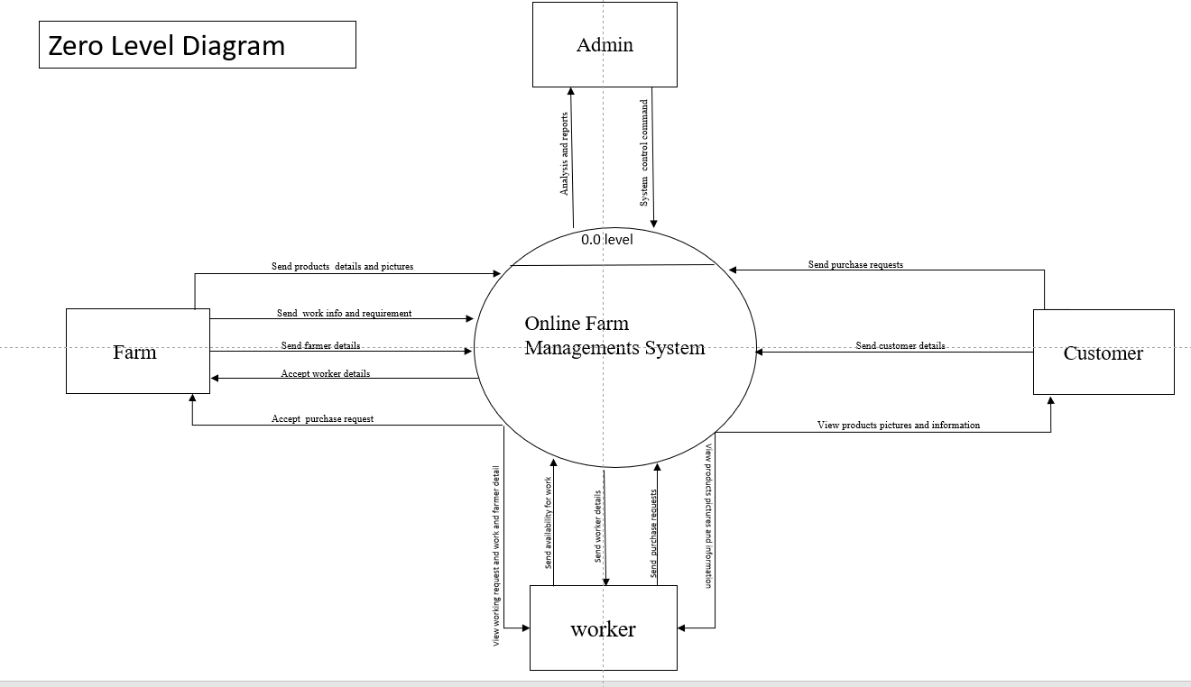

**First Level Data Flow Diagram**

Farmer

Send registration Details

­Manage Registration Details

Admin

Report And Analysis

Report And Analysis

Send worker request

Send registration Details

Worker

Log in Data

Manage Site

View work request

Send registration Details

Report And Analysis

Login Data

Login Data

View Post

View Post

Report And Analysis

Make Payment

Customer

**E-R Diagram**

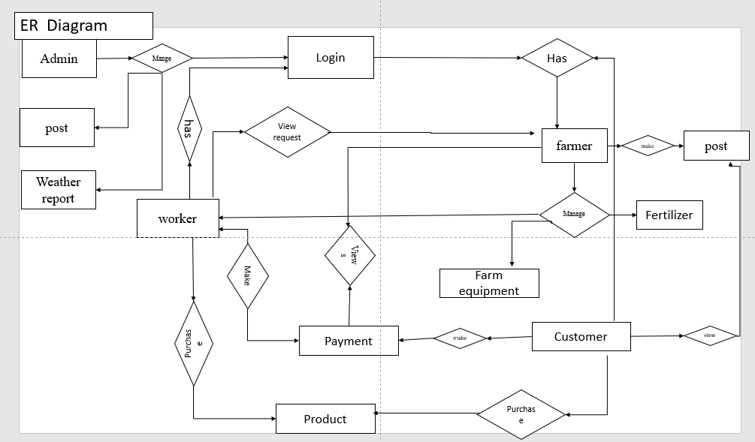

**ACTIVE CASE DIAGRAM**

**ADMINE**



**FARMER**



**CLASS CASE DIAGRAM**

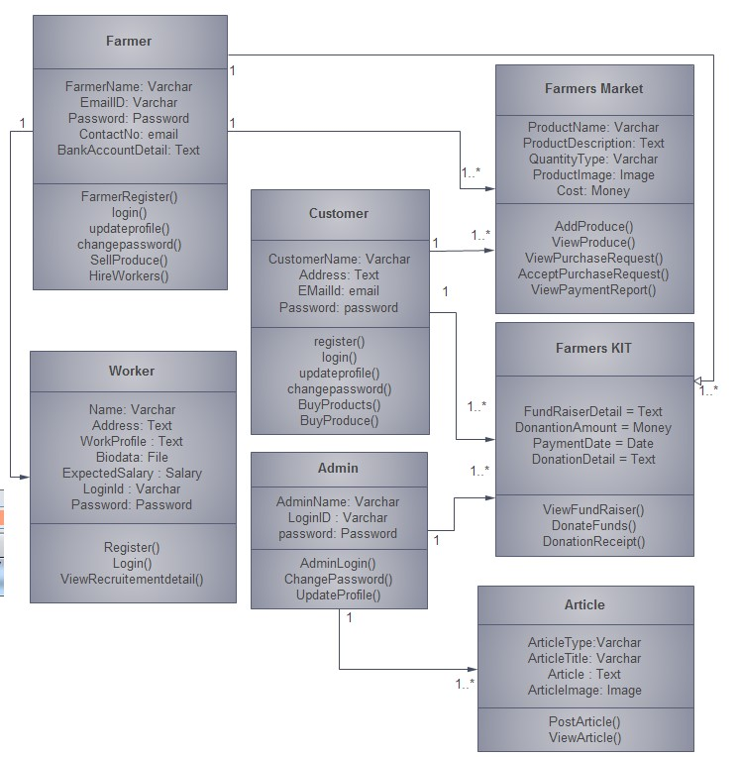

**SEQUENCE DIAGRAM FOR FARMER**



**SEQUENCE DIAGRAM FOR ADMINISTRATORE**



**SEQUENCE DIAGRAM FOR WORKER**



**USE CASE DIAGRAM**



**HARDWARE AND SOFTWARE REQUIREMENT**

**Software Requirements**

|  |  |
| --- | --- |
| Programming Language | Html , CSS, PHP , MYSQL |
| Database | Firebase ,MySQL |
| Text Editor | Sublime Text |
| IDE | Android Studio |
| Operating System | Windows XP/7/8/10/11pro |

**Hardware Requirements**

|  |  |
| --- | --- |
| RAM | 2GB or more 4GB or more recommended especially for Microsoft windows 11 |
| Hard Disk | Min.250 GB |
| Processor | Dual Core and Above  Snapdragon965 and above |

**OUT PUT AND MISSION AND VISION AGRICLUTURE**

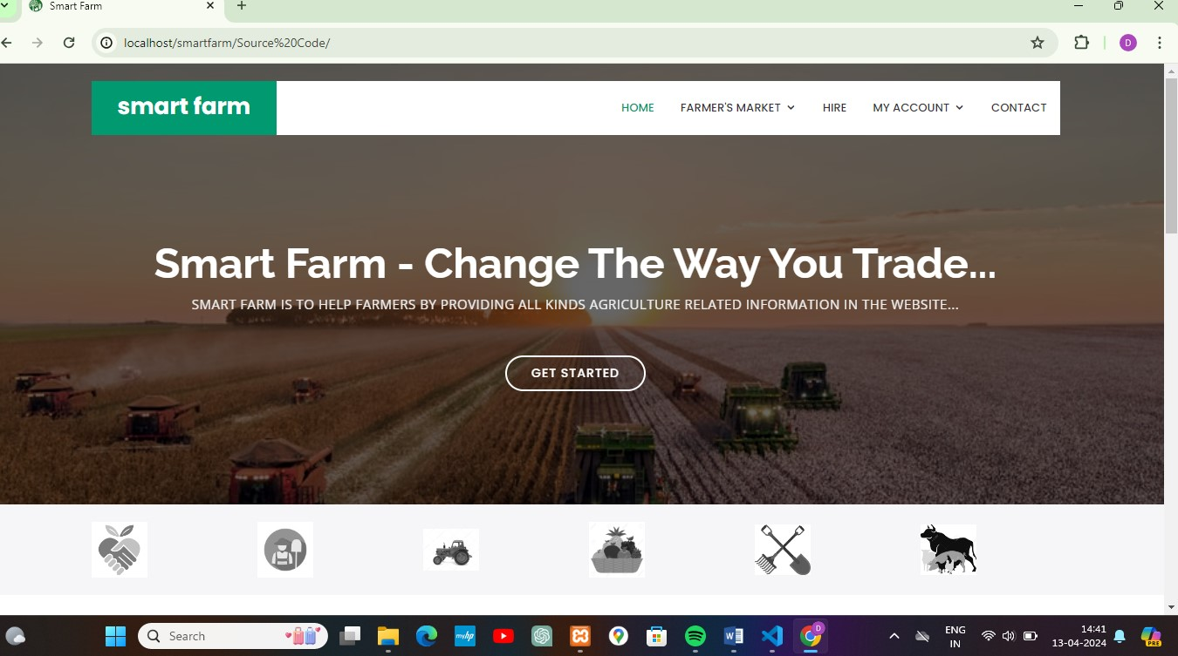

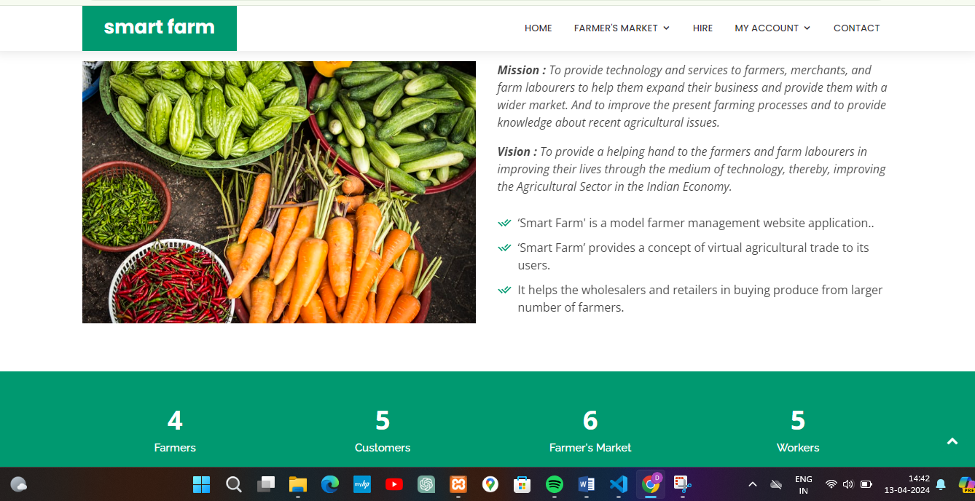

**HIRE LABOURE IN AGRICLUTURE**

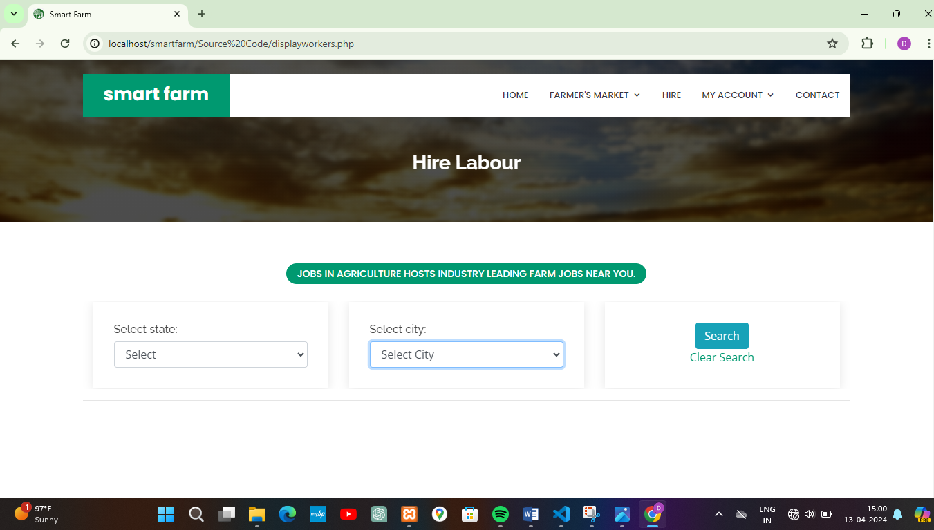

**CUSTOMER & FARMAR WORKER LOGIN REGISTER**

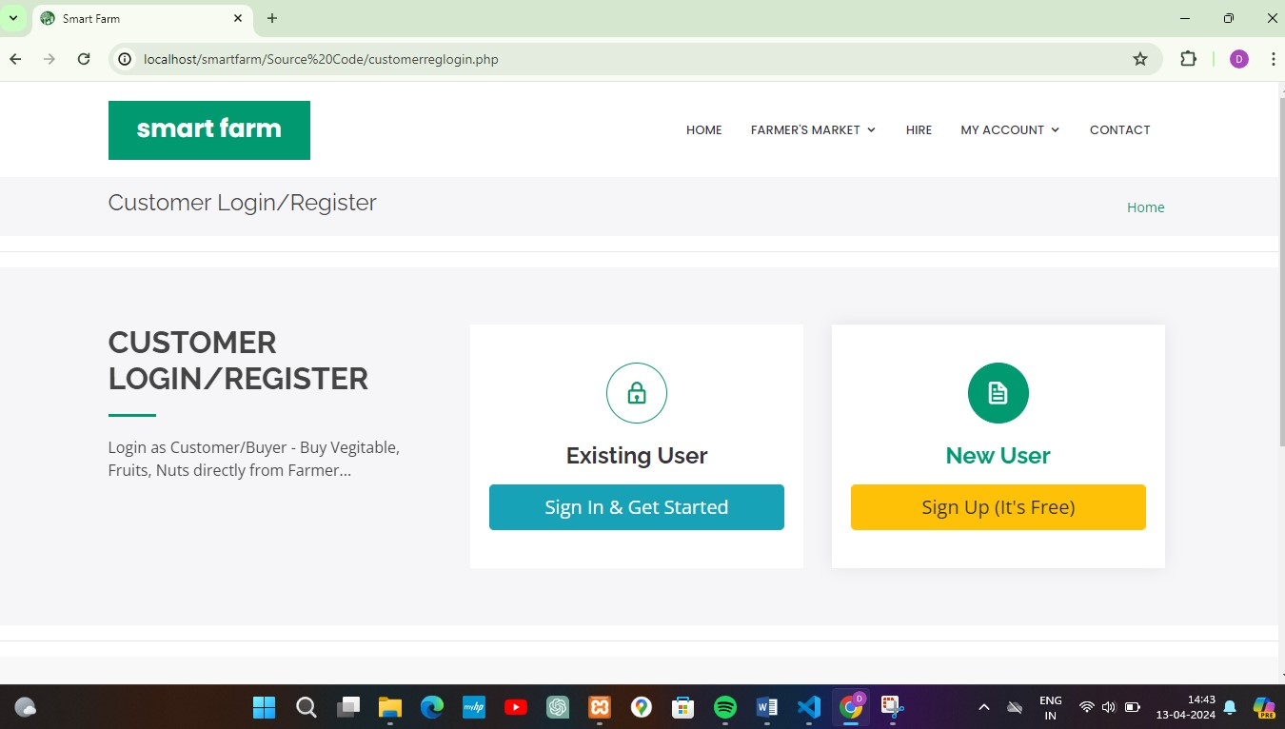

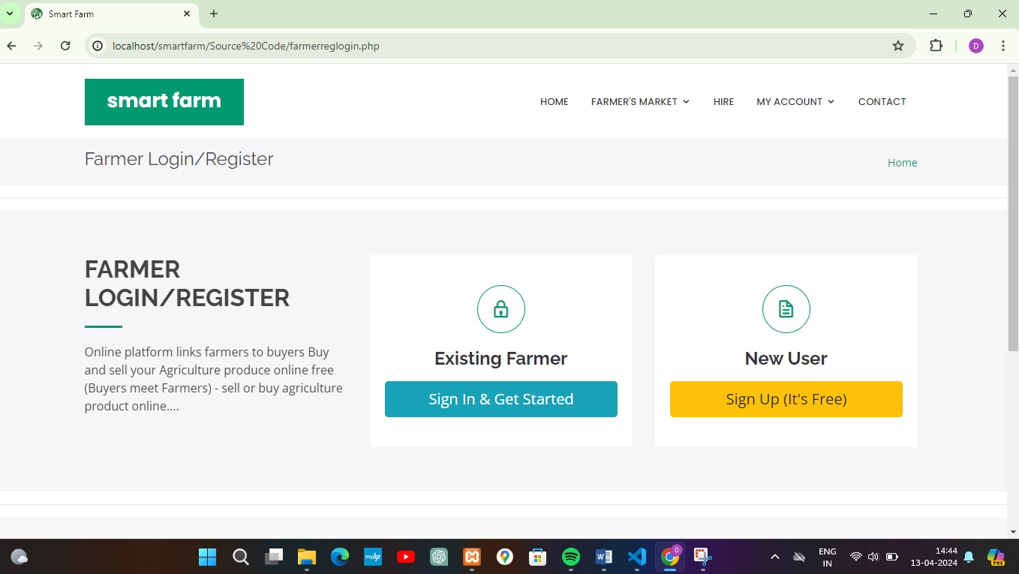

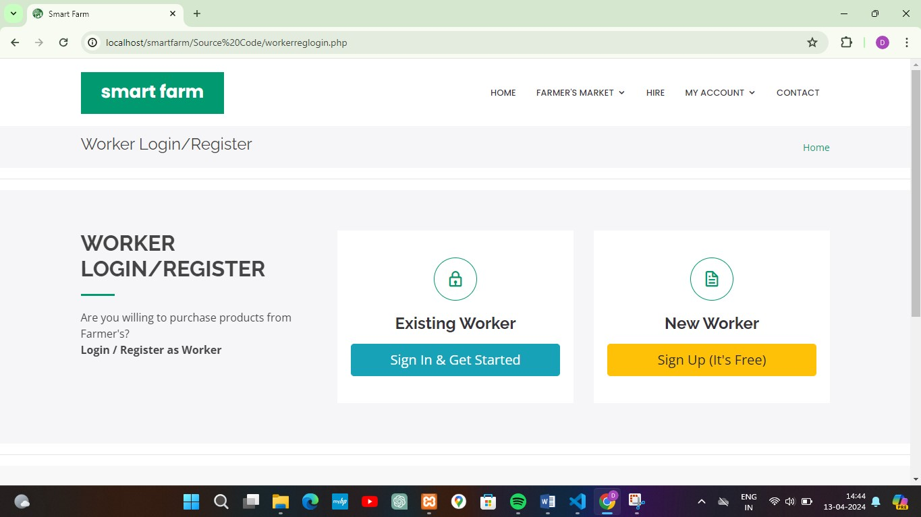

**LOGIN PANEL**

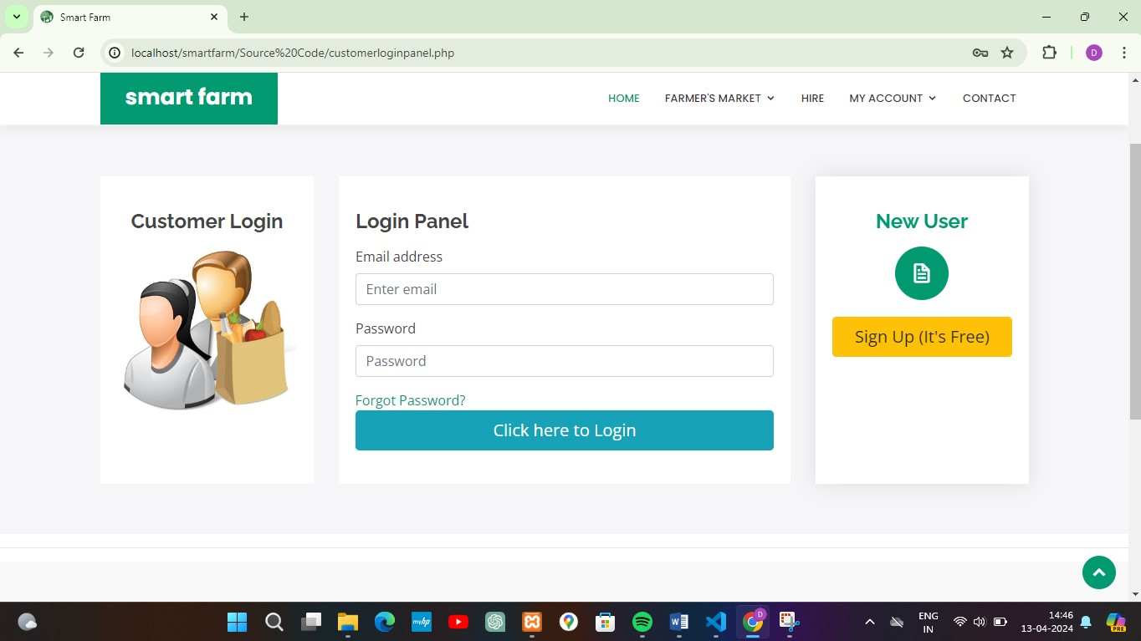

**WORKER REGISTRATION PANEL**

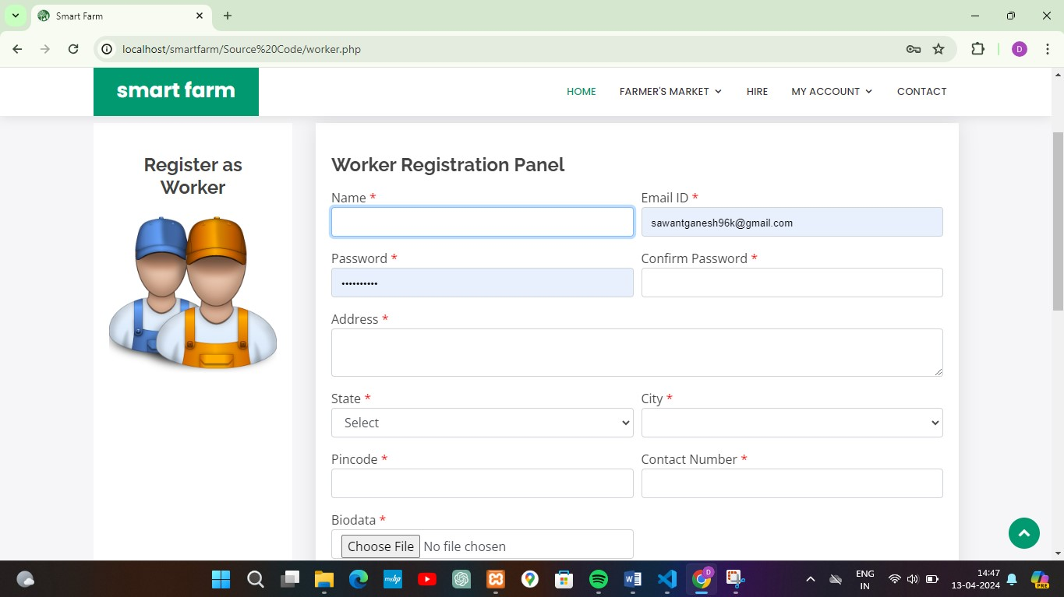

**DATABASES**

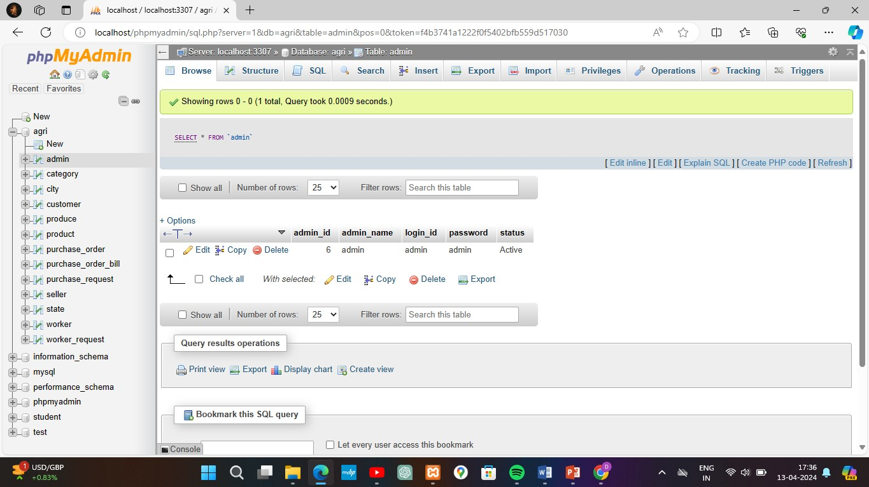

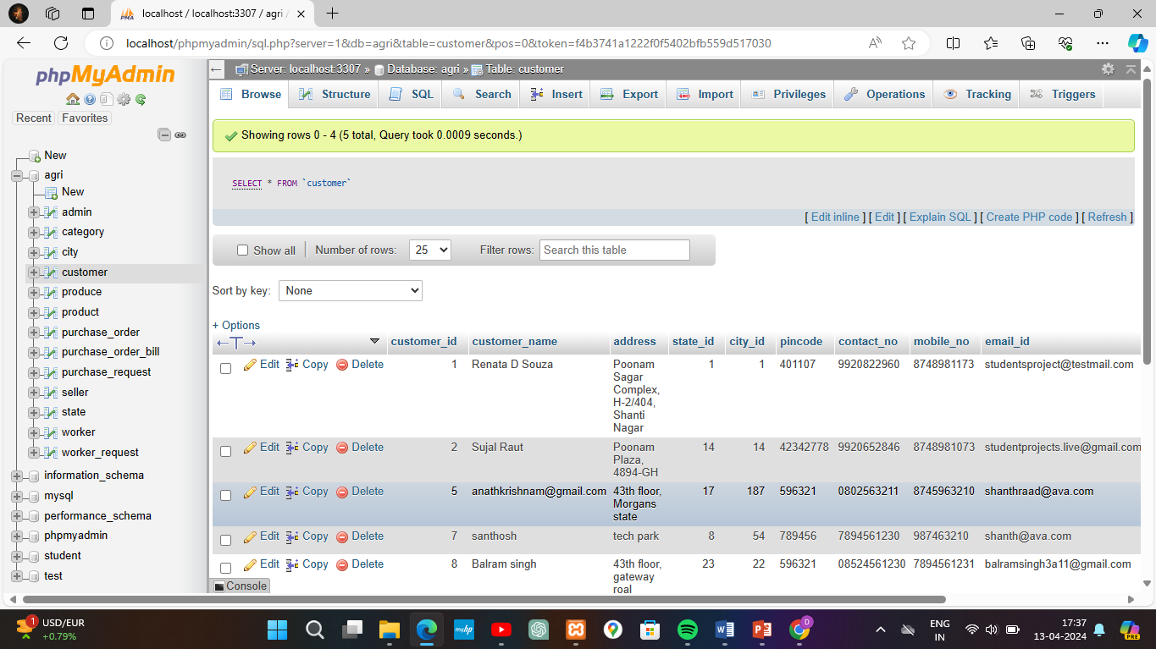

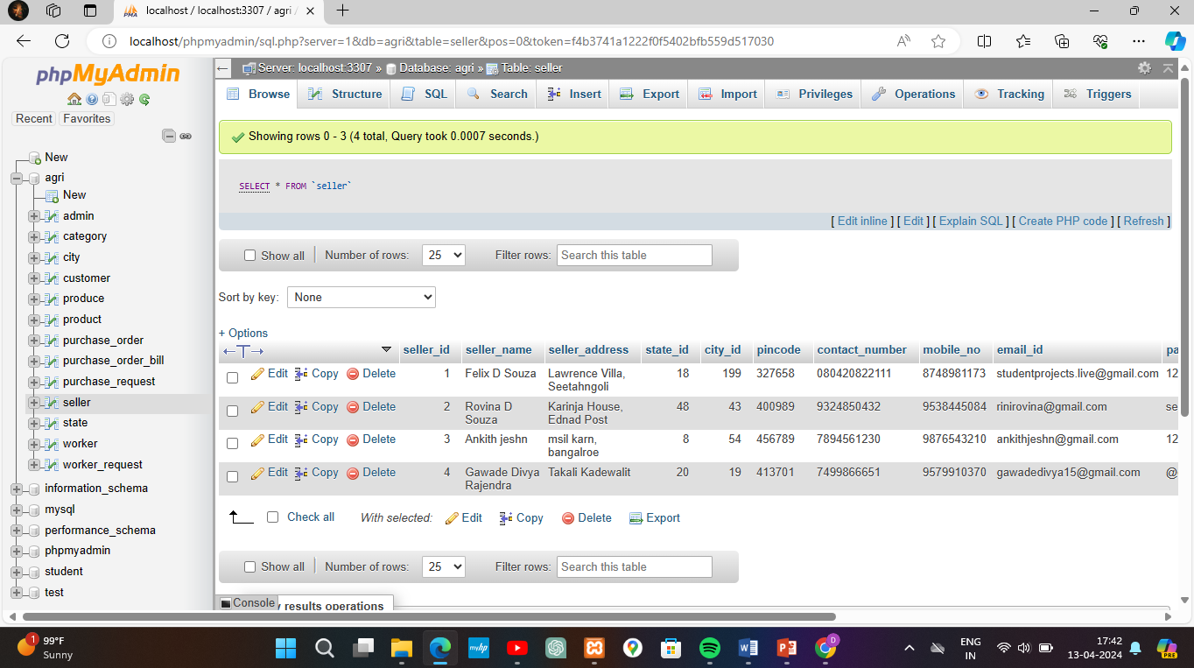

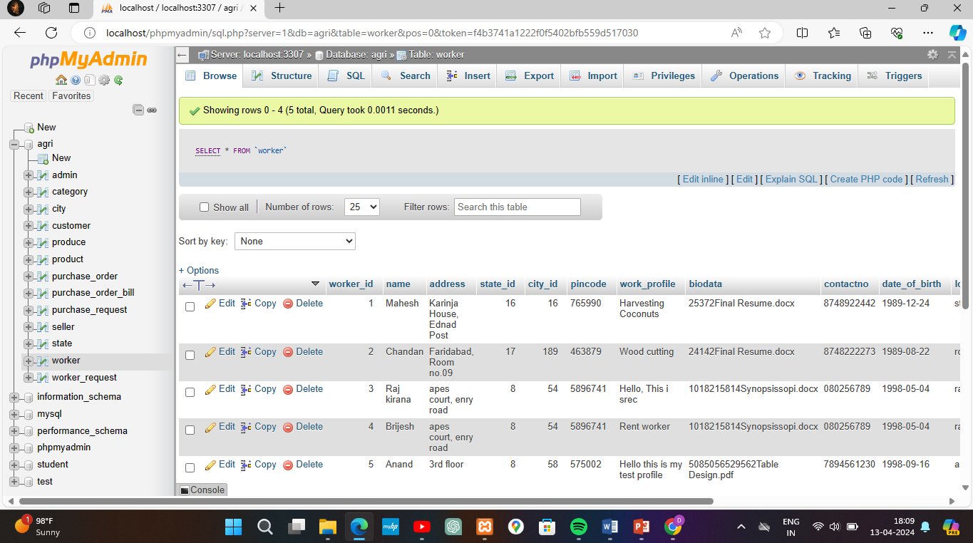

**CONCLUSION**

The project smart farming mobile application” is a mam made project and, therefore there may be mistake and limitation the idea put up may be different.

The advanced techniques like sensors technology can be used in the future for measuring the quality of the product.

The goal of smart farming is to produce more with less.

The agricultural sector is of vital importance for the region.

**BIBLIOGRAPHY**

WEBSITE

[www.google.in](http://www.google.in/)

[www.youtube.in](http://www.youtube.in/)

<http://www.w3school.com>